2003 IIHF WORLD CHAMPIONSHIP IN FINLAND

RENTAL FURNITURE - catalog

WC-Express furniture

Prices during the World Championship games

PRODUCT | PRODUCT INFORMATION | rental price €/piece  (VAT 0%) | PICTURE
1  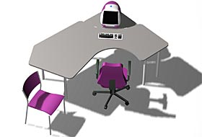  Basic table | colour: beech  Foldable tablelegs  Sizes: 80x160 cm  80x120 cm | 80x160 cm  42€  80x120 cm  39€
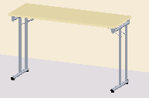  2  Folding table | colour: beech  Folding tablelegs,  size: 45x120 cm | 37€
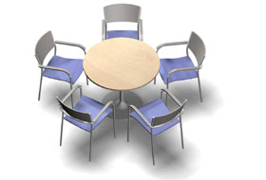  3  Round table | colour: beech  Normal height  - diameter 60cm  - diameter 90 cm | 42€
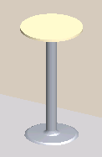  4  Bar table | colour: beech  Height 110 cm, trumpetleg  diameter 60 cm | 35€
5  Parente7 –chair | birchveneer, without upholstery, stained, colour: pearl grey | 24€ | 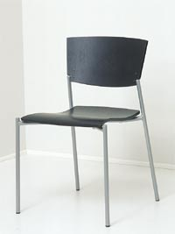
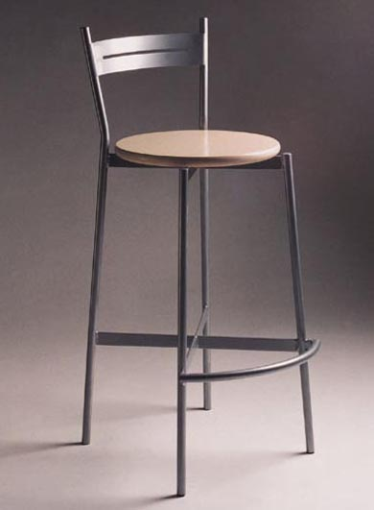  6  Bar chair | Metal legs/birchveneer,  without upholstery | 28€

7  Parente 6 -chair | birch veneer/seat upholstered,  arm restsstained,  colour: pearl grey  upholstery: blue | 45€ | 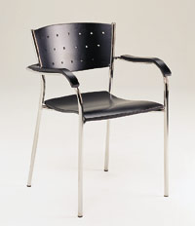
8  Info-desk | Tables laminated veneer,  front sheet of metal,  Half circular,  size: 190 x 95 cm | 260€ | 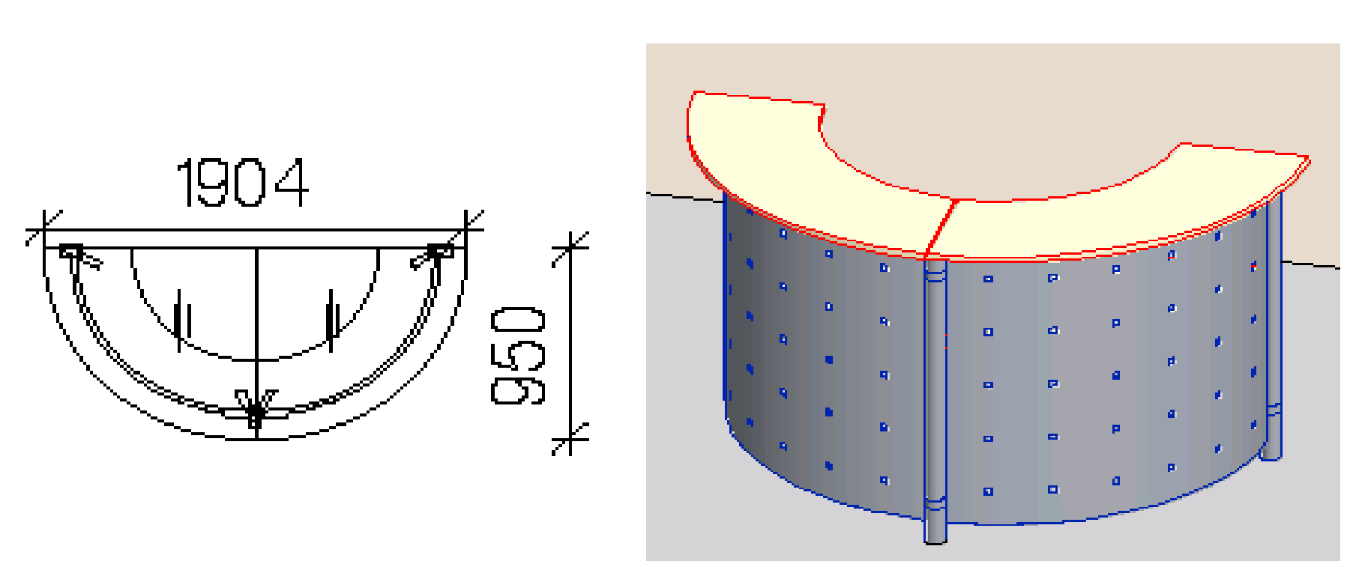
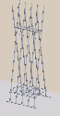  9  Coat rack | Metal colour:  silver grey | 36€
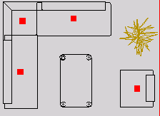  10  2 seated sofa  11  Armchair  12  Sofa, corner  13  Coffee table | seating height 450 mm  seating depth 630 mm  variety of colours  Coffeel table 100 x 60 cm  height: 54 cm | 2 seated sofa  185€  armchair  145€  sofa. corner  205€  coffee table | 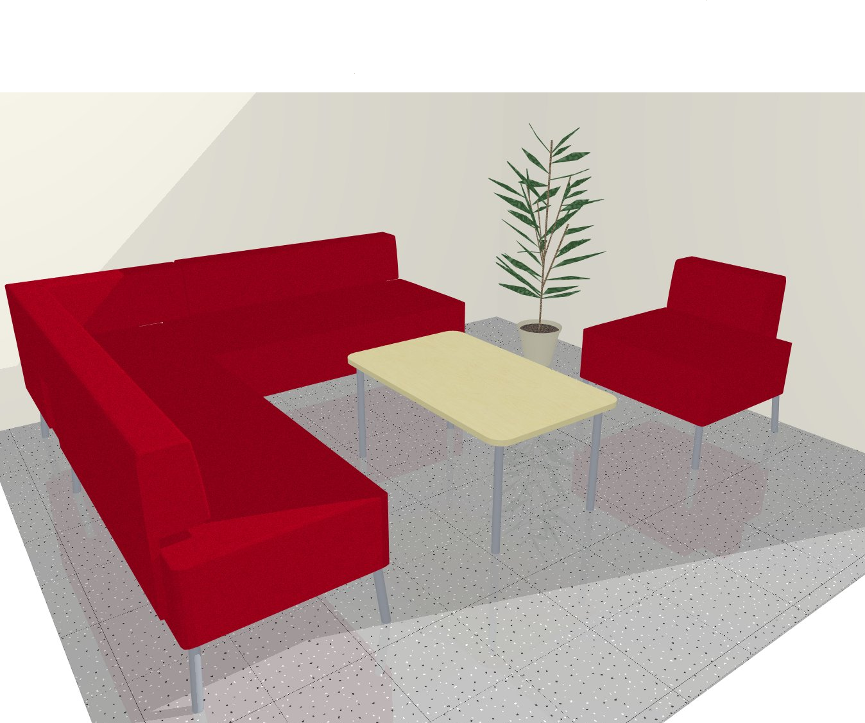
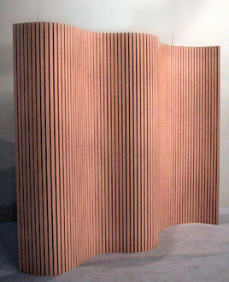  14  Screen | Tambour,  Flexible and freestanding  laminated veneer; beech  height 150 cm  width when straigh 200 cm | 80€
15  ”Steel” -screen | steel  Width 79 cm  height about 200 cm | 80€ | 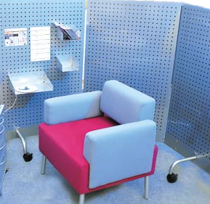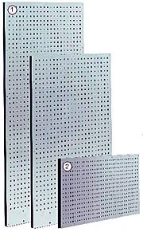
16  Refrigerator  17 Coffee maker | KTI5L400  122 liter  19 liter freezer  Porche Design | 100€  60€

Furniture for working premises

PRODUCT | PRODUCT INFORMATION | € PRICES, VAT 0% | PICTURE
BASIC 7B  left handed table in the picture  OFFICE DESK | adjustable monitor desk top,  right or left handed,  beech or rst-laminated veneer,  silver grey table legs | 185€ | 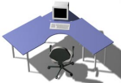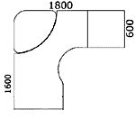
STEEL 1C  left handed table in the picture  OFFICE DESK | adjustable monitor desk top,  right or left handed,  beech or rst-laminated veneer,  silver grey table legs | 185€
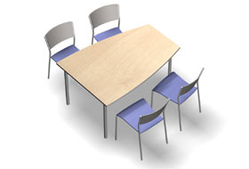  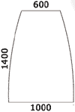  CONFERENCE  TABLE 5A | beech or RST- laminated veneer,  silver grey table legs | 125€
PEDESTRIAL | Beech or rst- laminated veneer,  Equipped with castors,  lockable | 79€
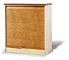  CABINET WITH  TAMBOUR DOOR | Beech or rst –laminated veneer,  metal feet,  lockable | 85€
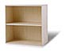  OPEN  CABINET (stackable) | beech or rst –laminated veneer | 30€
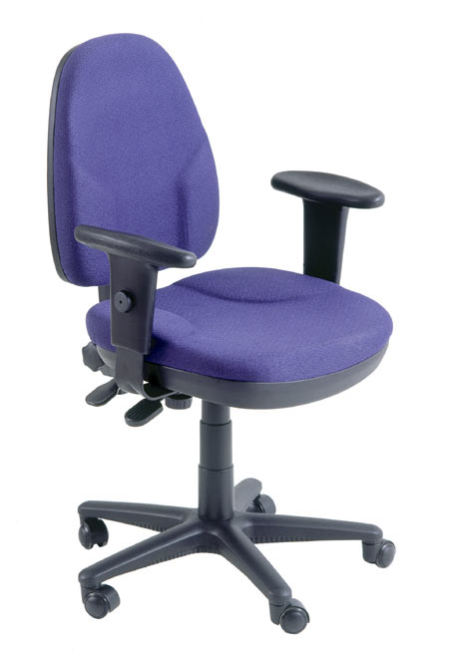EXPRESS OFFICE CHAIR | Adjustable armrests, colour; blue,  castors | 90€

